**ASSESSMENT OF CRANIAL NERVES**

Match the following assessment tools with the nerve to be tested.

1. Cotton ball 1. Vestibulocochlear (VIII)

2. Snellen chart 2. Accessory (XI)

3. Use of hands to check neck/shoulder strength 3. Trigeminal (V)

4. Tuning fork or whisperer 4. Optic (II)

5. Tongue blade and cotton swab 5. Vagus (X)

**CRITICAL THINKING Exercise**

Read the following case study and answer the following questions.

Mrs. Pickett is admitted to the nursing home where you work as a nurse. She had a stroke 2 weeks

ago and is not strong enough to go to a rehabilitation facility. She has left-sided weakness. You

collect admitting data to help determine her plan of care.

1. Mrs. Pickett tells you she needs to get up to go to the bathroom. What are some things you can

do to determine if she is able to do this?

2. Mrs. Pickett's first meal is served. What can you do to determine her ability to eat safely?

3. Mrs. Pickett says, “Will you go to the kitchen and get me one of those cookies

I like?" How do you determine whether she is confused?

4. Mrs. Pickett is weak on her left side. Why do you think her blood pressure will be more accurate

in her right arm?

**VOCABULARY**

*Fill in the blank with the correct term.*

1. Difficulty swallowing is called _____________________
2. An ______________ is a test that uses scalp electrodes to evaluate brain activity.
3. A patient might say his leg feels like it is asleep to describe ____________________________.
4. Abnormal flexion posturing when eliciting best motor response is called _____________posturing.
5. Abnormal extension posturing when eliciting best motor response is called _____________________posturing.
6. ______________ is the term that describes unequal pupils.
7. Involuntary eye movement is called __________
8. Permanent muscle contractions are called ___________________

9. Difficulty speaking because of muscle dysfunction is called ______

_______________________.

10. Patients who have difficulty speaking after a stroke are experiencing ___________________________________________.

**Label Parts of the Cerebellum**



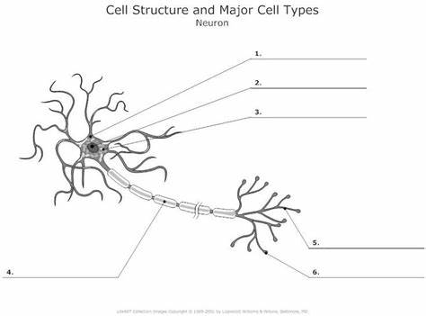

**Glasgow Coma Scale Review:**

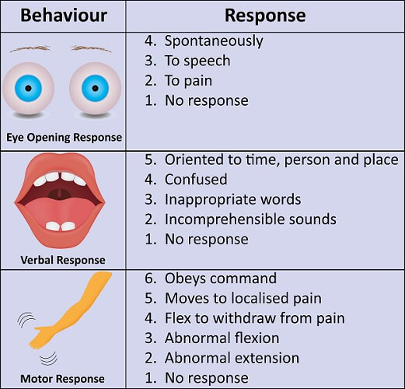

Q1. What are the three components of the Glasgow Coma Scale?

1.  Eyes, Motor, Memory
2.  Eyes, Motor, Pain
3.  Eyes, Verbal, Motor

Q2. Each of the three components of the Glasgow Coma Scale have a number of steps. Which of these are the correct combinations?

1.  Eyes 5 Verbal 4 Motor 6
2.  Eyes 4 Verbal 5 Motor 5
3.  Eyes 4 Verbal 5 Motor 6

Q3. What possible sequence of responses is assessed in the eye component?

1.  Spontaneous, To Sound, To Pressure, None
2.  Spontaneous, None, To Pain, To Sound
3.  To Pressure, None, To Spoken Word, Spontaneous

Q4. In each component of the Glasgow Coma Scale the ‘Best Response’ is,

1.  No response
2.  Spontaneous
3.  A normal response

Q5. When assessing a patient, you should:

1.  Observe, Move, Feel, Rate
2.  Check, Observe, Stimulate, Rate
3.  Look, Feel, Rate, Stimulate

Q6. When assessing a patient, what is the reason for the CHECK step in the assessment?

1.  To listen for sounds from the patient
2.  To identify factors that may interfere with the assessment
3.  To look at the previous Glasgow Coma Scale assessment on the patient’s chart

Q7. If when you approach the patient they are awake and looking at you, how would you record this on the Glasgow Coma Scale?

1.  Spontaneous eye opening
2.  Orientated
3.  Obeying commands

Q8. You are called to see a patient who has fallen through a plate glass door. As you approach the patient you observe that their eyes are extremely swollen and they are unable to open them. How would you record the eye component of the scale?

1.  None
2.  To pain
3.  Eyes Not testable (NT)

Q9. A 45 year old man called Hamish is admitted to the Emergency Department on Sunday 1 January 2014 after being assaulted. When you ask the patient to tell you his name, where he is and what the date is, he answers, Hamish, Hospital, December. How would you record this finding?

1.  Orientated
2.  Confused
3.  Words

Q10. You are assessing the motor component of a patient’s Glasgow Coma Scale. They are unable to obey commands but bend their elbow when their finger nail bed is stimulated. What do you do next?

1.  Record ‘Normal Flexion’
2.  Apply supraorbital notch pressure
3.  Apply a trapezius Pinch

Q11. A patient reacts to supraorbital pressure by moving their hand up to his face. How would you record this response?

1.  Normal Flexion
2.  Extension
3.  Localizes

Q12. Normal flexion, where a patients elbow bends and their arm moves rapidly away from their body and from a stimulus, is given what number in the Glasgow Coma Scale?

1.  Motor 2
2.  Motor 4
3.  Motor 1

Q13. If you were told by a colleague that their assessment of a patient’s Glasgow Coma Scale was E2, V3, M5, how would you interpret this?

1.  The patient’s eyes open to sound, they are orientated are able to obey commands
2.  The patient’s eyes open to pressure, they can utter some words but do not form sentences, and they are able to localize to trapezius pinch.
3.  The patient’s eyes open spontaneously; they are orientated and able to obey commands

Q14. In which of these scenarios of assessment of the motor component of the Glasgow Coma Scale is the best response on the patient’s right-hand side?

1.  R arm localizes, L arm flexing
2.  R arm no response, L arm extension
3.  R arm localizes, L arm obeys commands

